Performance Specification
Model |  |  | V_{max} | V_{max} |  |  | Maximum Time |  | Resistance
Model | I_{hold} | Itrip | Operating | Interrupt | I_{max} | P_{d} | To Trip
Model | (MA) | (MA) | (Vdc) | (Vrms) | (A) | Typ. | Current | Time | Ri_{min.} | Ri_{max.} | R1_{max}
Model |  |  |  |  |  | (W) | (A) | (Sec) | (Ω) | (Ω) | (Ω)
250V40mA | 40 | 80 | 60 | 250 | 3.0 | 1.00 | 0.5 | 0.2 | 30 | 60 | 80
250v 60mA | 60 | 120 | 60 | 250 | 3.0 | 1.00 | 0.5 | 0.5 | 20 | 40 | 60
250v 80mA | 80 | 160 | 60 | 250 | 3.0 | 1.00 | 1.00 | 0.25 | 14 | 22 | 33
250v90mA | 90 | 180 | 60 | 250 | 3.0 | 1.00 | 1.00 | 0.5 | 10 | 20 | 31
250V110mA | 110 | 220 | 60 | 250 | 3.0 | 1.00 | 1.00 | 1.1 | 6 | 12 | 16
250v120mA | 120 | 240 | 60 | 250 | 3.0 | 1.00 | 1.00 | 1.2 | 6 | 11 | 16
250V 145mA | 145 | 290 | 60 | 250 | 3.0 | 1.00 | 1.00 | 2.5 | 3.5 | 6.5 | 12
250V 180mA | 180 | 360 | 60 | 250 | 10 | 1.8 | 3.00 | 1.5 | 1 | 3 | 5
250V200mA | 200 | 400 | 60 | 250 | 10 | 2.4 | 3.00 | 5 | 3 | 6 | 9
250V400mA | 400 | 800 | 60 | 250 | 10 | 2.8 | 3.00 | 8 | 1 | 3 | 5
250V600mA | 600 | 1200 | 60 | 250 | 10 | 3.2 | 3.00 | 10 | 0.6 | 2.0 | 4
250V800mA | 800 | 1600 | 60 | 250 | 10 | 3.6 | 3.00 | 20 | 0.4 | 1.0 | 3
V max = Maximum operating voltage device can withstand without damage at rated current (Imax).
I max = Maximum fault current device can withstand without damage at rated voltage (V max).
I hold = Hold Current. Maximum current device will not trip in 25°C still air.
I trip = Trip Current. Minimum current at which the device will always trip in 25°C still air.
Pd = Power dissipation when device is in the tripped state in 25°C still air environment at rated voltage.
Ri min/max = Minimum/Maximum device resistance prior to tripping at 25°C.
R1max = Maximum device resistance is measured one hour post reflow.
CAUTION : Operation beyond the specified ratings may result in damage and possible arcing and flame.

Environmental Specifications
Test |  |  |  | Conditions |  |  |  | Resistance change
Passive aging |  |  |  | +85°C, 1000 hrs. |  |  |  | ±5% typical
Humidity aging |  |  |  | +85°C, 85% R.H. , 168 hours |  |  |  | ±5% typical
Thermal shock |  |  |  | +85°C to -40°C, 20 times |  |  |  | ±33% typical
Resistance to solvent |  |  |  | MIL-STD-202,Method 215 |  |  |  | No change
Vibration |  |  |  | MIL-STD-202,Method 201 |  |  |  | No change
Ambient operating conditions : - 40 °C to +85 °C
Maximum surface temperature of the device in the tripped state is 125 °C

Ihold Versus Temperature
Model | Maximum ambient operating temperature (T_{mao}) vs. hold current (I_{hold})
Model | -40°C | -20°C | 0°C | 25°C | 40°C | 50°C | 60°C | 70°C | 85°C

Soldering Parameters
Time
TP 260

100

25
Soldering
5Sea.MAX
Temperature(°C)
Gradual
Cooling

Pre-Heating
1 Minute Min.

WAVE SOLDERING INFORMATIONS
Pre-Heating Zone | Max. ramping rate should not exceed 4℃/Sec.
Soldering Zone | Max. solder temperature should not exceed 260℃
Cooling Zone | Cooling by natural convection in air.
◎Specifications are subject to change without notice.

Physical Dimensions(mm.)
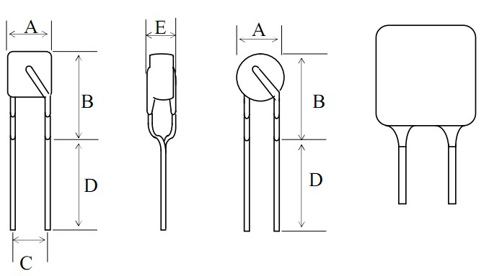
Model | A | B | C | D | E
Model | Max. | Max. | Typ. | Min. | Max.
250V040MA | 6.0 | 9.3 | 5.1 | 5.0 | 3.8
250V080MA | 6.0 | 9.3 | 5.1 | 5.0 | 3.8
250V090MA | 6.0 | 9.3 | 5.1 | 5.0 | 3.8
250V110MA | 6.5 | 10.0 | 5.1 | 5.0 | 3.8
250V120MA | 7.0 | 10.0 | 5.1 | 5.0 | 3.8
250V145MA | 7.0 | 10.0 | 5.1 | 5.0 | 3.8
250V180MA | 10.2 | 14.5 | 5.1 | 5.0 | 3.4
250V200MA | 10.5 | 17 | 5.1 | 5.0 | 3.8
250V400MA | 10.5 | 17 | 5.1 | 5.0 | 3.8
250V600MA | 16 | 18 | 5.1 | 5.0 | 4.5
250V800MA | 20 | 22 | 5.1 | 5.0 | 4.5

